**Course Specialist Year 12 Test Three 2022**

Student name: ________________ Teacher name: ________________

**Task type: Response**

**Time allowed for this task: _____40______ mins**

**Number of questions: _____6______**

**Materials required:** NO classpads nor calculators

Standard items: Pens (blue/black preferred), pencils (including coloured), sharpener, correction fluid/tape, eraser, ruler, highlighters

Special items: Drawing instruments, templates, notes on one unfolded sheet of   
A4 paper, and up to three calculators approved for use in the WACE examinations

**Marks available: __40____ marks**

**Task weighting: _10___%**

**Formula sheet provided: Yes**

**Note: All part questions worth more than 2 marks require working to obtain full marks.**

**NO classpads nor calculators!**

Q1 (3 & 3= 6 marks) (3.3.9-3.3.10)

1. Solve the following set of linear equations.



1. Consider the system below,



Determine the values of  such that there are:

1. Unique solution
2. Infinite solutions
3. No solutions.

Q2 (2, 2, 2 & 3 = 9 marks) (3.3.11, 3.3.13)

A particle moves such that at time  seconds the velocity is . The particle is initially at the origin.

Determine:

1. The position vector at time  second.
2. The acceleration of the particle at  second.
3. The speed of the particle at  seconds.
4. The time(s) when the velocity is perpendicular to the acceleration.

Q3 (4, 3 & 2 = 9 marks) (3.3.12, 3.3.13, 3.3.15)

Consider a particle that is projected from the top of a cliff of height 30 metres with a speed of  metres per second at an angle of  to the horizontal. Assume that the acceleration is constant at  towards the centre of the Earth. Let the origin of cartesian axes be at the base of the cliff as shown below with the appropriate unit vectors .

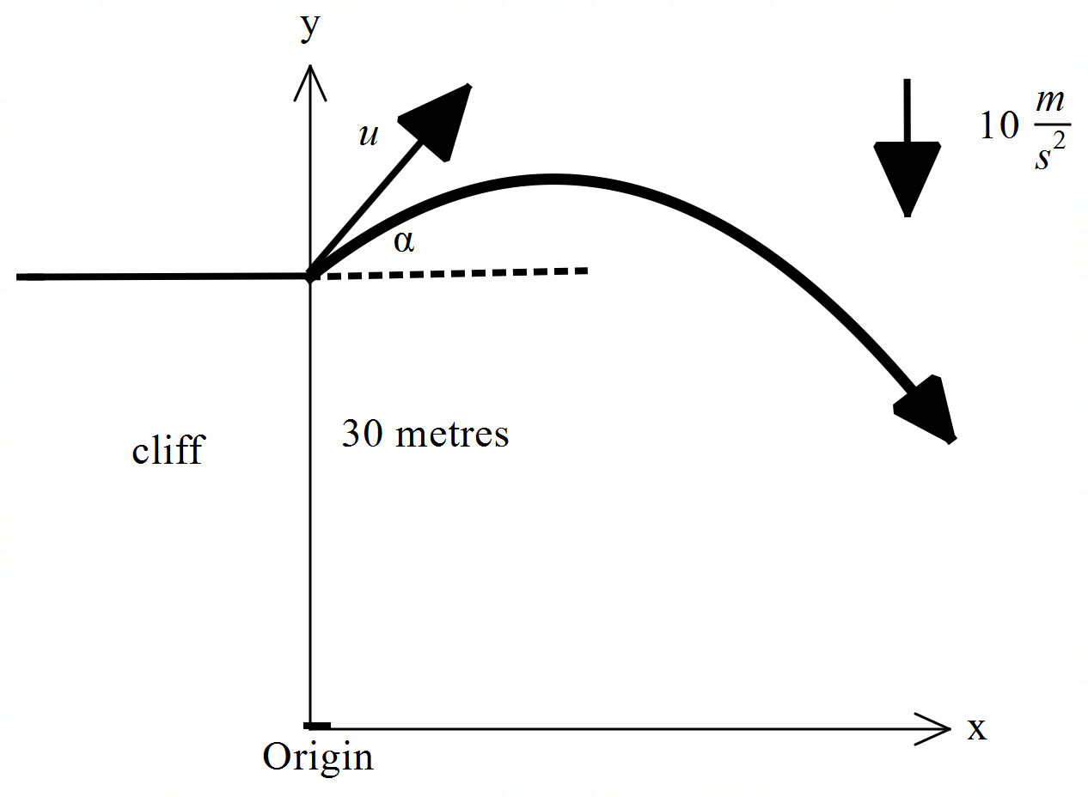

Let .

1. Using vector integration, show how to derive the position vector  at time  seconds in terms of . Show all steps.
2. Show how to derive the cartesian equation for the path of the particle in terms of .
3. Set up an equation in terms of  ONLY, but do not solve, that would allow the range

() to be determined where the particle hits the floor from the base of the cliff.

Q4 (4 marks) (4.2.1)

If , determine  in terms of only.

Q5 (3 & 4 = 7 marks) (4.2.1)

Determine the following integrals:

1. 
2. 

Q6 (5 marks) (4.1.1, 4.2.2)

Consider a lighthouse that is 50 metres away from the shore. On the shore is a long brick wall. The light on the lighthouse is rotating at 4 revolutions per second. Determine the exact speed of the dot of light on the wall at a point 3 metres from the point directly opposite the lighthouse as shown below.

